**Assignment 1**

**1. Basic Unix/Linux commands:**

* **ls**

ls is a Linux shell command that lists directory contents of files and directories

ls -t: It sorts the file by modification time, showing the last edited file first. head -1 picks up this first file

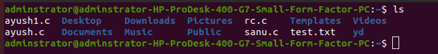

* **date**

date command is used to display the system date and time. date command is also used to set date and time of the system. By default, the date command displays the date in the time zone on which Unix/Linux operating system is configured. You must be the super-user (root) to change the date and time.

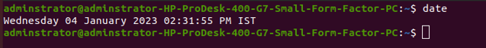

* **help**

help command just displays information about shell built-in commands.

**options**

* -d option: It is used when you just want to get an overview about any shell built-in command i.e it only gives short description.
* -m option: It displays usage in pseudo-manpage format.
* -s option: It just displays only a short usage synopsis for each topic matching.

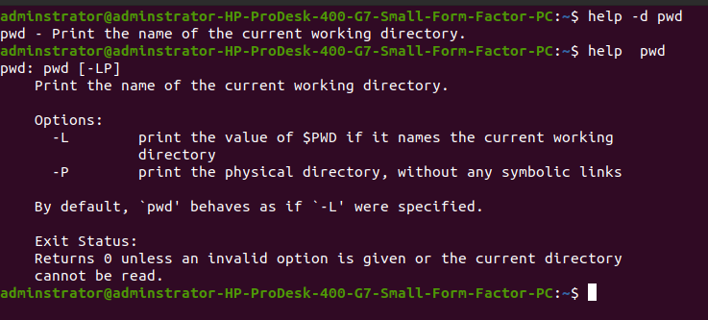

* **Info**

info command reads documentation in the info format. It will give detailed information for a command when compared with the man page. The pages are made using the texinfo tools because of which it can link with other pages, create menus and easy navigation.

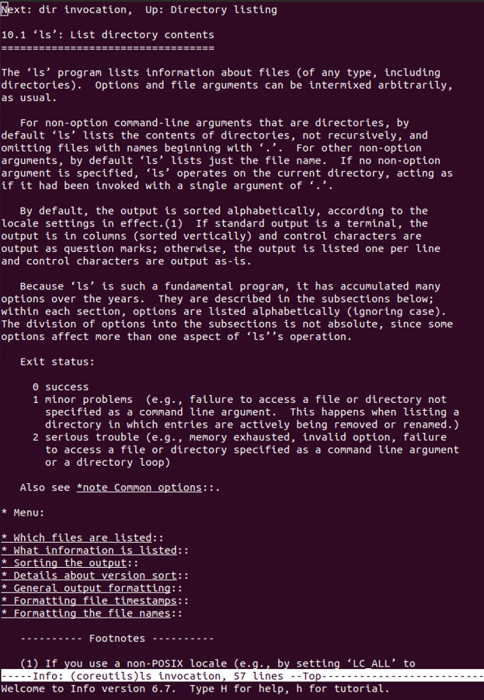

* **man**

***man*** command in Linux is used to display the user manual of any command that we can run on the terminal. It provides a detailed view of the command which includes NAME, SYNOPSIS, DESCRIPTION, OPTIONS, EXIT STATUS, RETURN VALUES, ERRORS, FILES, VERSIONS, EXAMPLES, AUTHORS and SEE ALSO.

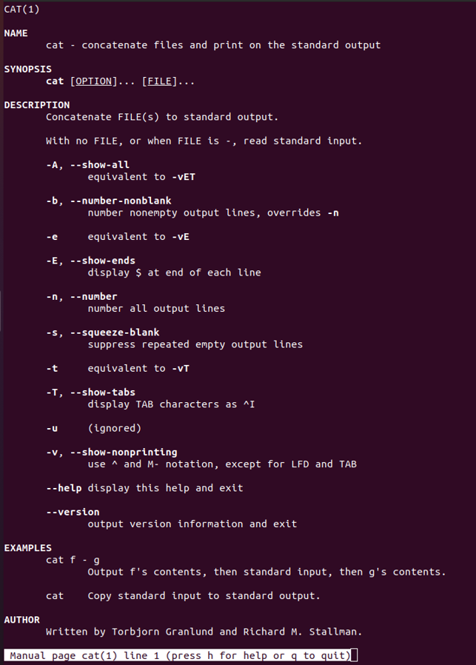

* **who**

shows current user information



* **pwd**

**pwd** stands for **P**rint **W**orking **D**irectory. It prints the path of the working directory, starting from the root.



* **cat**

It reads data from the file and gives their content as output. It helps us to create, view, concatenate files

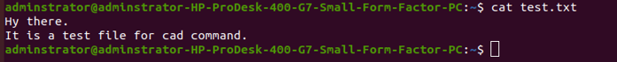

* **more**

more command is used to view the text files in the command prompt, displaying one screen at a time in case the file is large (For example log files). The more command also allows the user do scroll up and down through the page.

+/pattern: This option is used to search the string inside your text document.

